**Science Year 7 2022**

**Task 3 – Classification Biology Test**

Student Name: ______________________________________________________________

Teacher: ___________________________________________________________________

Section 1: Multiple Choice ______/ 10 marks

Section 2: Short Answer _______/ 31 marks

**Total: ______/ 41 Marks %**

**Section One: Multiple choice (10 marks)**

*Select the most correct answer*

1. Out of these animals: cat, dog, bird, rabbit, which is the odd one out?
2. Bird
3. Cat
4. Dog
5. Rabbit
6. A vertebrate is an animal:
7. that can fly
8. that does not have a backbone
9. that lives on land
10. that has a backbone
11. Which of the following is not a member of the plant kingdom?
12. trees
13. grass
14. moss
15. algae
16. What are three defining features of mammals?
17. they have hair, scales and feed milk to their young
18. they have hair, lay eggs and are endothermic (warm-blooded)
19. they have hair, are endothermic (warm-blooded) and feed milk to their young
20. none of the above
21. Select the level of classification in which organisms are the most **similar**:
22. Kingdom
23. Genus
24. Order
25. Species
26. The scientific name comes from combining the:

1. Family and species
2. Genus and species
3. Kingdom and phylum
4. Genus and the name of the scientist who discovered it
5. Which of the following is NOT a reason to use the scientific name of an organism, instead of the common name?
6. The scientific name contains useful information, such as the genus name, which tells what other species this organism is related to.
7. The scientific name is unique to each biological species, while the same common name may be applied to several different species.
8. The scientific name is easier to remember and is commonly used in conversation.
9. None of the above.
10. Which of the following characteristics will most likely be helpful in identifying a butterfly using a dichotomous key?
11. Migrates North every Spring
12. Hangs on branches
13. Flutters wings fast on hot days
14. Wings have long extensions

Questions 9 and 10 refer to the dichotomous key below

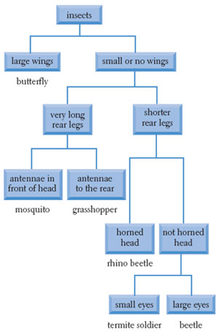

1. Which animal has the following features: small or no wings, long rear legs, and antennae to the front of their head
2. Beetle
3. Grasshopper
4. Mosquito
5. Termite soldier
6. Which of the following is a feature of a beetle
7. Long rear legs and antennae
8. Short rear legs and horned head
9. Not horned head and small eyes
10. Small or no wings and large eyes

**Section Two: Short Answer (31 marks)**

11. Describe using four characteristics of living things why fungi are considered ‘living’.   
 (4 marks)

___________________________________________________________________________

___________________________________________________________________________

___________________________________________________________________________

___________________________________________________________________________

_________________________________________________________________________________________________________________________________________________________________________________________________________________________________

12. Write the missing levels of classification in the list below in the correct space. (2 marks)

|  |
| --- |
| Kingdom |
|  |
|  |
| Order |
|  |
| Genus |
|  |

13. Compare and contrast the Kingdoms Protista and Monera (4 marks)

___________________________________________________________________________

___________________________________________________________________________

___________________________________________________________________________

______________________________________________________________________________________________________________________________________________________

______________________________________________________________________________________________________________________________________________________

______________________________________________________________________________________________________________________________________________________

14. Tick which features belong to the three classes of vertebrates listed below. (3 marks)

|  |  |  |  |  |
| --- | --- | --- | --- | --- |
| **Vertebrate** | Warm blooded | Feed offspring milk | Undergo meta-morphis | Have a spinal cord |
| **Reptiles** |  |  |  |  |
| **Mammals** |  |  |  |  |
| **Amphibian** |  |  |  |  |

15. Classify the following living things   
  
A. Dog (1.5 marks)

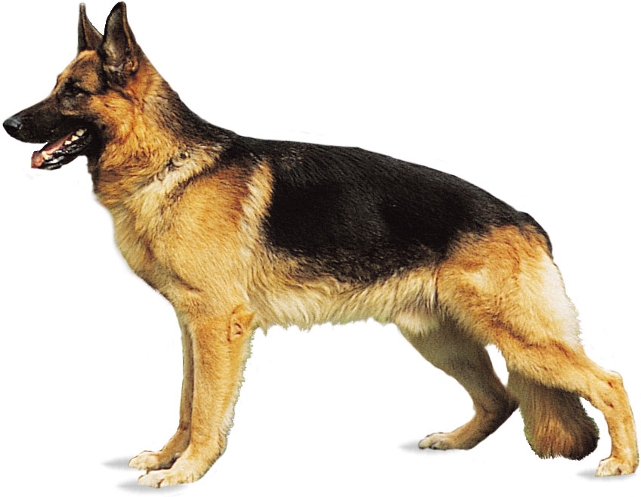

Kingdom ____________________________  
  
Phylum _____________________________  
  
Class _______________________________

B. Turtle (1.5 marks)

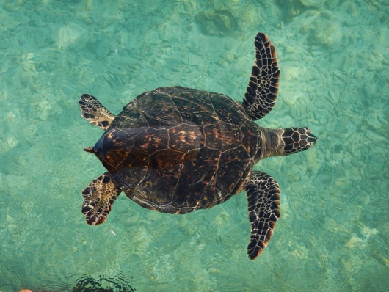

Kingdom ________________________________  
  
Phylum _________________________________  
  
Class ___________________________________

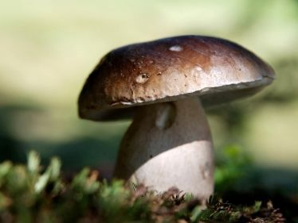D. Wild mushroom (0.5 mark)

Kingdom ___________________________

E. Bacteria (0.5 marks)

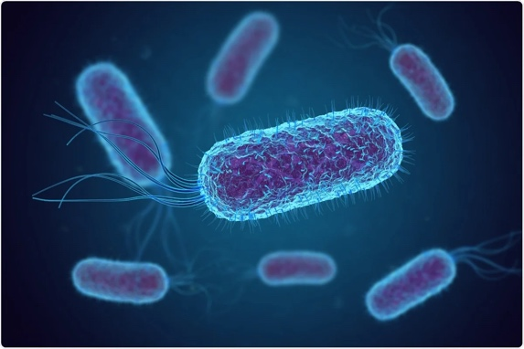

Kingdom ___________________________

16. A crocodile is a living thing. Can you describe why they are classified as below using their features. (3 marks)

Kingdom: Animalia  
Phylum: Chordata

Class: Reptile  
  
_______________________________________________________________________  
  
_______________________________________________________________________  
  
_______________________________________________________________________

_______________________________________________________________________

17. Use the dichotomous key below to answer the questions

1. What is the name of the yellow alien? ____________________________ (1 mark)

1. What are the features that are used to in the key determine the name of *Alienus stripicus?* (2 marks)

__________________________________________________________________________________________________________________________________________

1. Look at the species name of each of the aliens. What is clearly used to help name the species? Provide an example in your response (2 marks)

_______________________________________________________________________________________________________________________________________________________________________________________________________________

18. Create a **branching** dichotomous key for the animals below using **physical features only**. (6 marks)

Draw your key in the space below:

‘

**End of Test**

**Finished? Check all of your answers again, then attempt this wordsearch ☺**

